**Assignment No : 1**

**Name : Abhishek Shrikrushna Solanke   
Branch : CSE (Artificial Intelligence) - Div (A)  
Roll No : 381013  
PRN : 22310235**

**Title :**

Write a Python program to encrypt and decrypt text using the Play fair Cipher, Vignere Cipher, Simple columnar technique and  Rail fence technique

**Objective :**

1. To understand the working of classical ciphers and their role in cryptography.
2. To implement multiple classical encryption and decryption algorithms.
3. To build a single Python toolkit supporting Playfair, Vigenère, Columnar, and Rail Fence ciphers.
4. To enable both command-line and interactive usage for encrypting and decrypting messages.

**Theory :**

Classical ciphers are the foundation of modern cryptography. They use substitution and transposition techniques to transform plaintext into ciphertext, securing information during transmission.

This project implements four such ciphers:

1. **Playfair Cipher:** Uses a 5x5 matrix of letters derived from a keyword. Pairs of letters are encrypted based on their positions in the matrix.
2. **Vigenère Cipher:** A polyalphabetic substitution cipher that shifts letters using a repeating key.
3. **Columnar Transposition Cipher:** Reorders characters into columns based on a key and reads them in a specific order to produce ciphertext.
4. **Rail Fence Cipher:** Arranges plaintext in a zig-zag pattern across multiple “rails” and reads row by row to encrypt.

These ciphers demonstrate how information can be obscured using mathematical transformations and positional rearrangements, forming the conceptual base for modern cryptographic algorithms.

**Procedure :**

**Steps to Run the Classical Cipher Toolkit:**

1. **Setup Environment**  
   Install Python (≥3.10 recommended).
2. **Save the Program File**  
   Save the following code as classical_ciphers.py.
3. **Interactive Mode (No arguments):**
4. python classical_ciphers.py
   1. Choose a cipher (Playfair, Vigenère, Columnar, Rail Fence).
   2. Select operation: Encrypt or Decrypt.
   3. Enter text and key (or rails).
   4. View the result instantly.

**Code :**

"""Assignment 1: Classical cipher toolkit .”””

from __future__ import annotations

import argparse

import itertools

import math

import string

import sys

from typing import Dict, List, Sequence, Tuple

ALPHABET = string.ascii_uppercase

# Utility helpers

def _clean_text(text: str, *, keep_space: bool = False) -> str:

cleaned = [ch.upper() for ch in text if ch.isalpha() or (keep_space and ch.isspace())]

return "".join(cleaned)

def _chunk_pairs(text: str) -> List[str]:

pairs: List[str] = []

idx = 0

while idx < len(text):

first = text[idx]

second = text[idx + 1] if idx + 1 < len(text) else "X"

if first == second:

pairs.append(first + "X")

idx += 1

else:

pairs.append(first + second)

idx += 2

if pairs and len(pairs[-1]) == 1:

pairs[-1] += "X"

return pairs

def _build_playfair_matrix(key: str) -> Tuple[List[List[str]], Dict[str, Tuple[int, int]]]:

sanitized = _clean_text(key)

seen: Dict[str, bool] = {}

matrix_letters: List[str] = []

def add_letter(letter: str) -> None:

letter = "I" if letter == "J" else letter

if letter in seen:

return

seen[letter] = True

matrix_letters.append(letter)

for char in sanitized:

add_letter(char)

for char in ALPHABET:

if char == "J":

continue

add_letter(char)

matrix = [matrix_letters[i : i + 5] for i in range(0, 25, 5)]

positions: Dict[str, Tuple[int, int]] = {}

for r, row in enumerate(matrix):

for c, char in enumerate(row):

positions[char] = (r, c)

return matrix, positions

def playfair_encrypt(text: str, key: str) -> str:

matrix, pos = _build_playfair_matrix(key)

pairs = _chunk_pairs(_clean_text(text))

result: List[str] = []

for first, second in pairs:

r1, c1 = pos[first]

r2, c2 = pos[second]

if r1 == r2:

result.append(matrix[r1][(c1 + 1) % 5] + matrix[r2][(c2 + 1) % 5])

elif c1 == c2:

result.append(matrix[(r1 + 1) % 5][c1] + matrix[(r2 + 1) % 5][c2])

else:

result.append(matrix[r1][c2] + matrix[r2][c1])

return "".join(result)

def playfair_decrypt(cipher: str, key: str) -> str:

matrix, pos = _build_playfair_matrix(key)

cleaned = _clean_text(cipher)

pairs = [cleaned[i : i + 2] for i in range(0, len(cleaned), 2) if len(cleaned[i : i + 2]) == 2]

result: List[str] = []

for first, second in pairs:

r1, c1 = pos[first]

r2, c2 = pos[second]

if r1 == r2:

result.append(matrix[r1][(c1 - 1) % 5] + matrix[r2][(c2 - 1) % 5])

elif c1 == c2:

result.append(matrix[(r1 - 1) % 5][c1] + matrix[(r2 - 1) % 5][c2])

else:

result.append(matrix[r1][c2] + matrix[r2][c1])

return "".join(result)

# Vigenère cipher

def vigenere_encrypt(text: str, key: str) -> str:

cleaned = _clean_text(text, keep_space=True)

key_stream = itertools.cycle(_clean_text(key))

result: List[str] = []

for ch in cleaned:

if ch.isspace():

result.append(ch)

continue

shift = ord(next(key_stream)) - ord("A")

offset = (ord(ch) - ord("A") + shift) % 26

result.append(chr(offset + ord("A")))

return "".join(result)

def vigenere_decrypt(cipher: str, key: str) -> str:

cleaned = _clean_text(cipher, keep_space=True)

key_stream = itertools.cycle(_clean_text(key))

result: List[str] = []

for ch in cleaned:

if ch.isspace():

result.append(ch)

continue

shift = ord(next(key_stream)) - ord("A")

offset = (ord(ch) - ord("A") - shift) % 26

result.append(chr(offset + ord("A")))

return "".join(result)

# Columnar transposition cipher

def _columnar_order(key: str) -> List[int]:

cleaned_key = _clean_text(key)

enumerated = sorted(enumerate(cleaned_key), key=lambda item: (item[1], item[0]))

order = [None] * len(cleaned_key)

for position, (original_index, _) in enumerate(enumerated):

order[original_index] = position

return order # type: ignore

def columnar_encrypt(text: str, key: str) -> str:

cleaned = _clean_text(text, keep_space=False)

order = _columnar_order(key)

width = len(order)

if width == 0:

raise ValueError("Key must contain alphabetic characters")

rows = math.ceil(len(cleaned) / width)

padded = cleaned.ljust(rows * width, "X")

grid = [padded[i : i + width] for i in range(0, len(padded), width)]

columns: List[str] = [""] * width

for row in grid:

for idx, char in enumerate(row):

columns[order[idx]] += char

return "".join(columns)

def columnar_decrypt(cipher: str, key: str) -> str:

order = _columnar_order(key)

width = len(order)

if width == 0:

raise ValueError("Key must contain alphabetic characters")

rows = math.ceil(len(cipher) / width)

base_len = rows * width

cipher = cipher.ljust(base_len, "X")

column_lengths = [rows] * width

slices: Dict[int, str] = {}

start = 0

for column_index in range(width):

length = column_lengths[column_index]

slices[column_index] = cipher[start : start + length]

start += length

reordered_columns = ["" for _ in range(width)]

for idx, column_pos in enumerate(order):

reordered_columns[idx] = slices[column_pos]

plaintext_chars: List[str] = []

for row_idx in range(rows):

for col_idx in range(width):

plaintext_chars.append(reordered_columns[col_idx][row_idx])

return "".join(plaintext_chars).rstrip("X")

# Rail fence cipher

def railfence_encrypt(text: str, rails: int) -> str:

if rails < 2:

raise ValueError("Rails must be at least 2 for rail fence cipher")

cleaned = _clean_text(text, keep_space=False)

fence = ["" for _ in range(rails)]

rail = 0

direction = 1

for char in cleaned:

fence[rail] += char

rail += direction

if rail == 0 or rail == rails - 1:

direction *= -1

return "".join(fence)

def railfence_decrypt(cipher: str, rails: int) -> str:

if rails < 2:

raise ValueError("Rails must be at least 2 for rail fence cipher")

length = len(cipher)

pattern = _rail_pattern(length, rails)

rail_lengths = [pattern.count(r) for r in range(rails)]

idx = 0

rails_content: List[List[str]] = []

for count in rail_lengths:

rails_content.append(list(cipher[idx : idx + count]))

idx += count

rail_indices = [0] * rails

result_chars: List[str] = []

for rail in pattern:

result_chars.append(rails_content[rail][rail_indices[rail]])

rail_indices[rail] += 1

return "".join(result_chars)

def _rail_pattern(length: int, rails: int) -> List[int]:

pattern: List[int] = []

rail = 0

direction = 1

for _ in range(length):

pattern.append(rail)

rail += direction

if rail == 0 or rail == rails - 1:

direction *= -1

return pattern

# Command-line interface

def _build_parser() -> argparse.ArgumentParser:

parser = argparse.ArgumentParser(description="Classical cipher toolkit")

parser.add_argument("cipher", choices=["playfair", "vigenere", "columnar", "railfence"], help="Cipher to use")

parser.add_argument("mode", choices=["encrypt", "decrypt"], help="Operation mode")

parser.add_argument("--text", required=True, help="Plaintext or ciphertext input")

parser.add_argument("--key", help="Key used by the cipher")

parser.add_argument("--rails", type=int, help="Number of rails (rail fence only)")

return parser

def _interactive_session() -> None:

print("Classical Cipher Toolkit (interactive mode)")

print("Available ciphers:")

options = {

"1": "playfair",

"2": "vigenere",

"3": "columnar",

"4": "railfence",

}

for number, name in options.items():

print(f" {number}. {name.title()}")

cipher_choice = None

while cipher_choice not in options:

cipher_choice = input("Select cipher [1-4]: ").strip()

cipher = options[cipher_choice]

mode_choice = None

while mode_choice not in {"e", "d"}:

mode_choice = input("Encrypt or decrypt? [e/d]: ").strip().lower()

mode = "encrypt" if mode_choice == "e" else "decrypt"

text = input("Enter the text: ")

key = None

rails = None

if cipher == "railfence":

while True:

rails_input = input("Enter number of rails (>=2): ").strip()

try:

rails_value = int(rails_input)

except ValueError:

print("Please enter a valid integer.")

continue

if rails_value < 2:

print("Rails must be at least 2.")

continue

rails = rails_value

break

else:

while not key:

key = input("Enter the key: ").strip()

if cipher == "playfair":

func = playfair_encrypt if mode == "encrypt" else playfair_decrypt

result = func(text, key)

elif cipher == "vigenere":

func = vigenere_encrypt if mode == "encrypt" else vigenere_decrypt

result = func(text, key)

elif cipher == "columnar":

func = columnar_encrypt if mode == "encrypt" else columnar_decrypt

result = func(text, key)

else:

func = railfence_encrypt if mode == "encrypt" else railfence_decrypt

result = func(text, rails)

print("\nResult:")

print(result)

def main(argv: Sequence[str] | None = None) -> None:

if argv is None:

argv = sys.argv[1:]

if not argv:

_interactive_session()

return

parser = _build_parser()

args = parser.parse_args(argv)

text = args.text

key = args.key

if args.cipher == "railfence" and args.rails is None:

parser.error("--rails is required for the rail fence cipher")

if args.cipher != "railfence" and (not key):

parser.error("--key is required for this cipher")

if args.cipher == "playfair":

func = playfair_encrypt if args.mode == "encrypt" else playfair_decrypt

result = func(text, key)

elif args.cipher == "vigenere":

func = vigenere_encrypt if args.mode == "encrypt" else vigenere_decrypt

result = func(text, key)

elif args.cipher == "columnar":

func = columnar_encrypt if args.mode == "encrypt" else columnar_decrypt

result = func(text, key)

else: # railfence

func = railfence_encrypt if args.mode == "encrypt" else railfence_decrypt

result = func(text, args.rails)

print(result)

if __name__ == "__main__":

main()

**Output :**

**Example 1 – Playfair Cipher**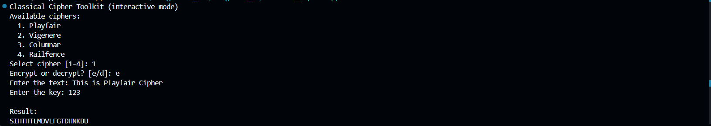

**Example 2 – Vigenère Cipher**

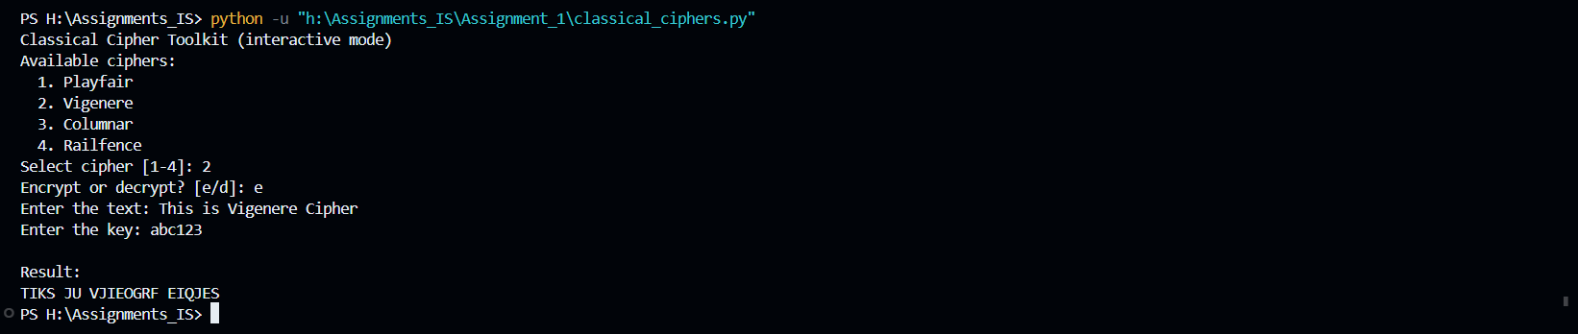

**Example 3 – Columnar Cipher**

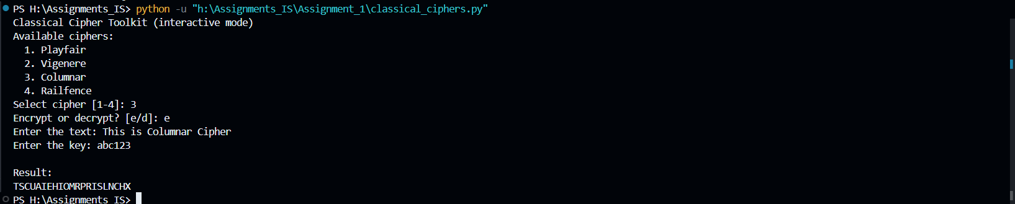

**Example 4 – Rail Fence Cipher**

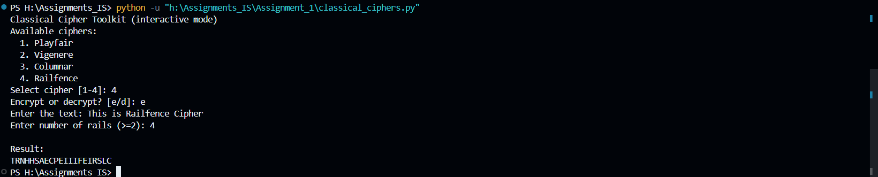

**Conclusion :**

This Classical Cipher code successfully implements multiple encryption and decryption algorithms from early cryptography. By integrating Playfair, Vigenère, Columnar, and Rail Fence ciphers into one Python program, it demonstrates the principles of substitution and transposition techniques.  
This project enhances understanding of manual encryption processes and provides a foundation for studying modern symmetric cryptography.